Insights from the interface feedback process
10th November 2016 (NU)

NOTE: Most of the discussion in this document addresses “the user” as the potential configurator, admin or manager of a new mazizone, and not the “end user” (person who encounters an instance of a mazizone in a particular location).

Summarising the main feedback points
- First point of contact:
It is important to consider the very first point of engagement that the potential user has with the toolkit. There should be explanation and information, well presented, in a simple way. This where a relationship with potential users begins.
- User characteristics:
People need time to understand and trust the concept of a mazizone. This is a relationship that has to be handled carefully and built slowly, so that the user only begins the technical set up when they are ready.
People want a rewarding experience, and they should be presented with appealing options that inspire them and that they can modify in ways that they feel in control of. The experience should maintain motivation for the user through the journey. These should be tangible, not too abstract, so that people can relate them to their own experiences and situation.
People’s own technical knowledge and experience differs widely. People have different expectations about how quickly they want to progress through a set-up process. Some people will want to progress in a straightforward route, others prefer a more exploratory, back and forth manner.
- Configuration Dashboard:
Before starting the configuration process, the user should have a clear idea of what they want to achieve, and an accurate understanding of how each element and choice they make contributes to that end goal. In order for the project to arrive at a shared understanding, a clear step-by-step flowchart is required to describe the order of the configuration process, eg, creating the disk image, setting up a mazizone, choosing applications, etc etc...
There should be a clear overview explaining which actions are carried out in which place. For example, will a disk image always be "unconfigured", with all the configuration actions taking place on the raspberry PI after the disk image is installed? Or can some configurations be carried out beforehand, and then loaded on to the disk image as a preconfigured package?
The interactions and choices made by the user in configuring the mazizone are complex. They must be stepped through clearly, in small sections, supported by appropriate explanation.
A user is likely to visit the configuration process many times to update and adjust settings. Applications may change and scenarios might evolve. Therefore the dashboard should be modular, with clearly separated elements.
- Hardware:
There are many possible hardware options and combinations. New versions of equipment will emerge over timescale of the project. Therefore the instructions and configuration process should be adaptable and modular so that new elements can be added simply.
- Knowledge & information:
There is a great deal of knowledge available within the MAZI consortium and from other sources. There should be consideration of how to present this knowledge, at the right points in the user journey, and in appropriate ways. A balance is needed between helpful, practical information, and motivational material.

User journey stages:
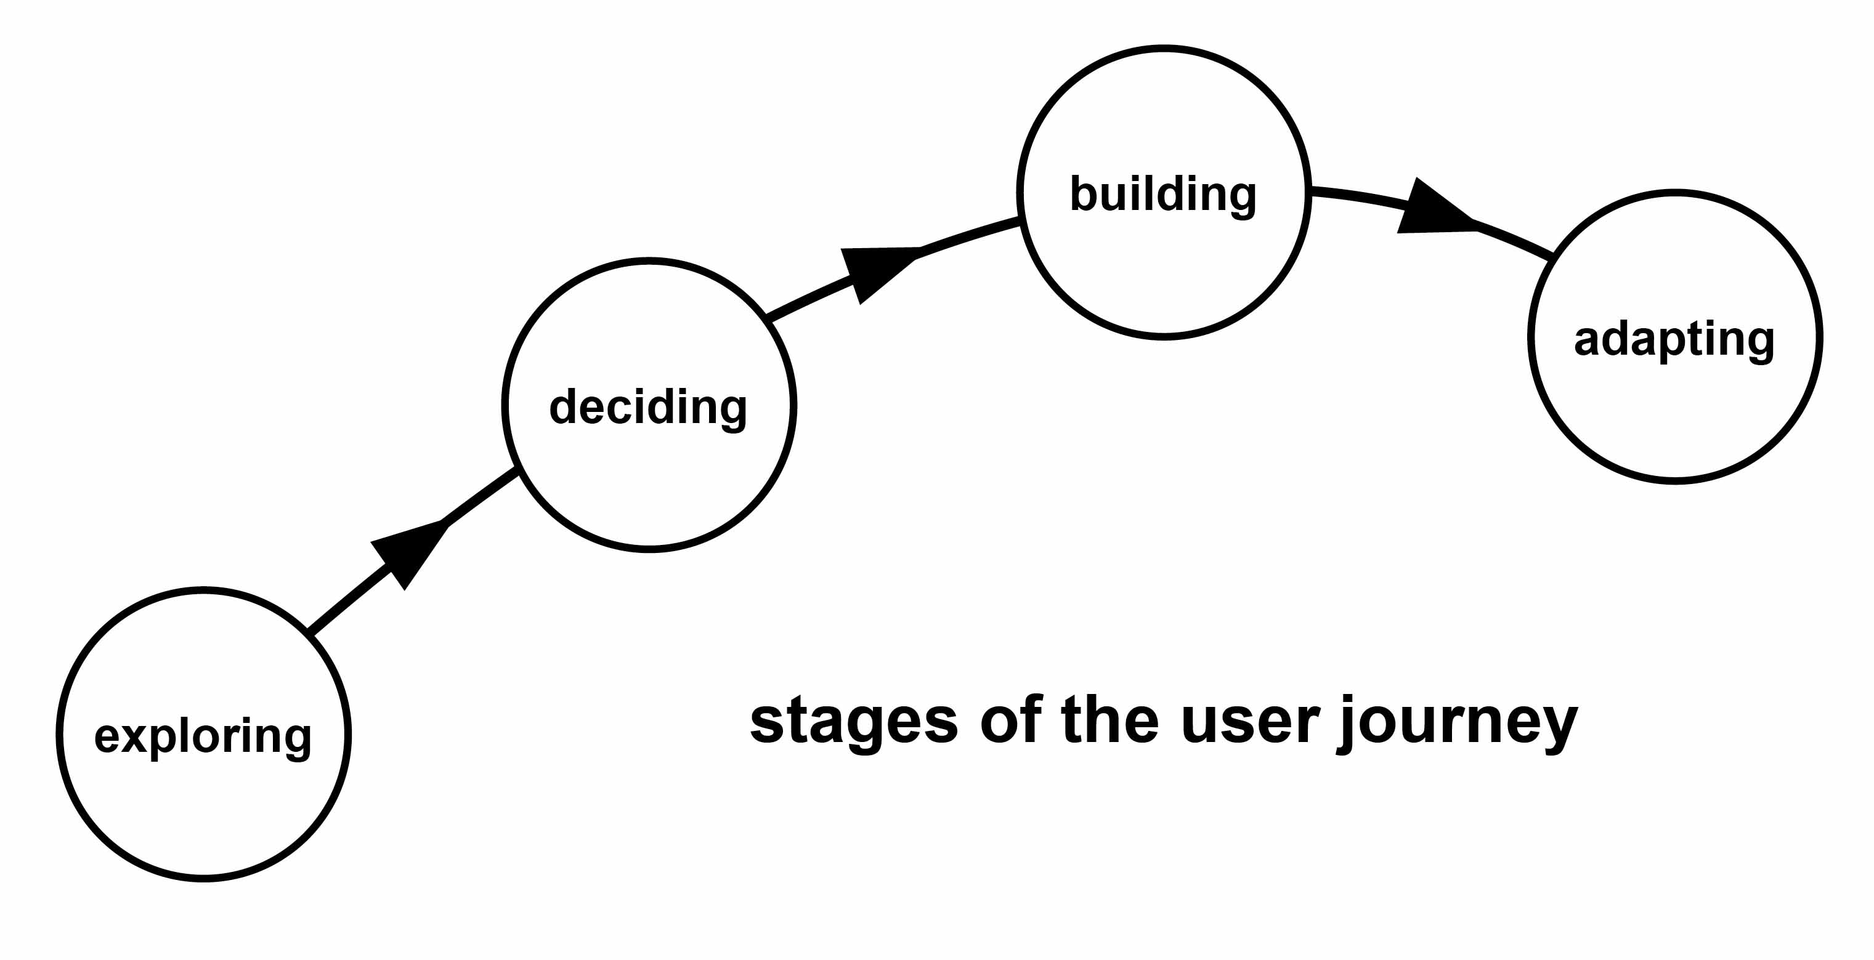
How someone goes through the journey of creating and running a MAZI toolkit

- Exploring – the user is interested in the MAZI concept and wants to know more about how it could work in their own situation. They need (a) concrete, practical examples and suggestions of how it could work, as well as (b) background information to support their motivation and enthusiasm. These should be clear, with images, not too much text.
- Deciding – Preparation stage. the user has decided to built a mazizone. They need help to get the right equipment organised, and to understand how much effort and time is required to create the zone. Hardware information could be included here.
- Building – in this stage the user is working in an intense way to configure the zone. Detailed help and support is needed, with lots of assistance in case things go wrong. Perhaps MAZI could present several timetabled “at a distance” making sessions where people are online together at a set time to share and help with chat support, photo sharing etc, along with the MAZI partners. These sessions could be promoted in advance so people have time to get organised. This could help to build a community feeling.
- Adapting – This is the long term relationship where the zone is altered, fixed, improved, updated and changed. Recording and sharing the results can be encouraged. For example, a collection on the MAZI toolkit website to share “My Mazizone” stories and photos. (example: http://www.ikeahackers.net/ )

Updated interface design elements (feedback requested please on this):
- The toolkit area of the current MAZI website: this will be developed and additional sections added. These will be designed to correspond to the 4 user journey stages described above, providing motivating, short and helpful pieces of information in a step-by-step way, including forums/ faqs etc.
My interpretation of what each user journey would translate to:
Exploring: Viewing the toolkit website, looking at examples etc.
Deciding: Purchasing hardware. Downloading an Image OR reading documentation to gain understanding of setup process. Perhaps if image route is chosen, writing image to the Pi and examining the default, built in applications.
Software used (potential): System admin panel
Building: Installing the base system environment if a mazi image has not been used.
Interacting with system administration page to configure things like network name and security.
Installing and configuring core applications based on needs
Software Used: System admin panel, Application administration panel, Application repository. Individual application config programs as required.
Adapting: Further configuration of applications based on needs.
Installation of new applications, removal of old applications.
Perhaps base system maintenance (updating linux packages)
Perhaps re-imaging and reconfiguring system (for example, if a new mazi image version was released)
Software used: all mentioned previously
- The “Application Dashboard”: this is a website hosted on the Thessaly server that provides access to all the selected MAZI applications. Information about each one is provided, (in a similar way to https://apps.sandstorm.io/) Collections of apps can be downloaded. There will be suggestions about which apps would work together as collections for particular purposes: “MAZI packages” eg. “discourse”, “knowledge”. Instructions will be provided in a clear way for how to include these applications within the mazizone.
This is a nice practical solution.
A possible alternative which may be easier from a software perspective could be to have the “Application Dashboard” Be a page which is bundled on the system image and run from the raspberry pi. This would communicate with the server to retrieve application info, pictures etc then download and install applications when selected.
- The “Configuration Dashboard”: This is the interface for configuring the network settings for the mazizone. It works together with the current mazi-guide for setting up a mazizone.
Depending on the applications chosen, there may be difficulties in interfacing between the dashboard and the settings of the actual application. Also possible duplication of functionality which applications themselves may provide?
- Splash page (captive portal) configuration: Quite a simple interface for customising the look, colour (CSS styles), logo, name, password etc. of the zone's captive portal. This is the area that users will see on their devices when they connect to the mazizone and begin to interact with the apps.

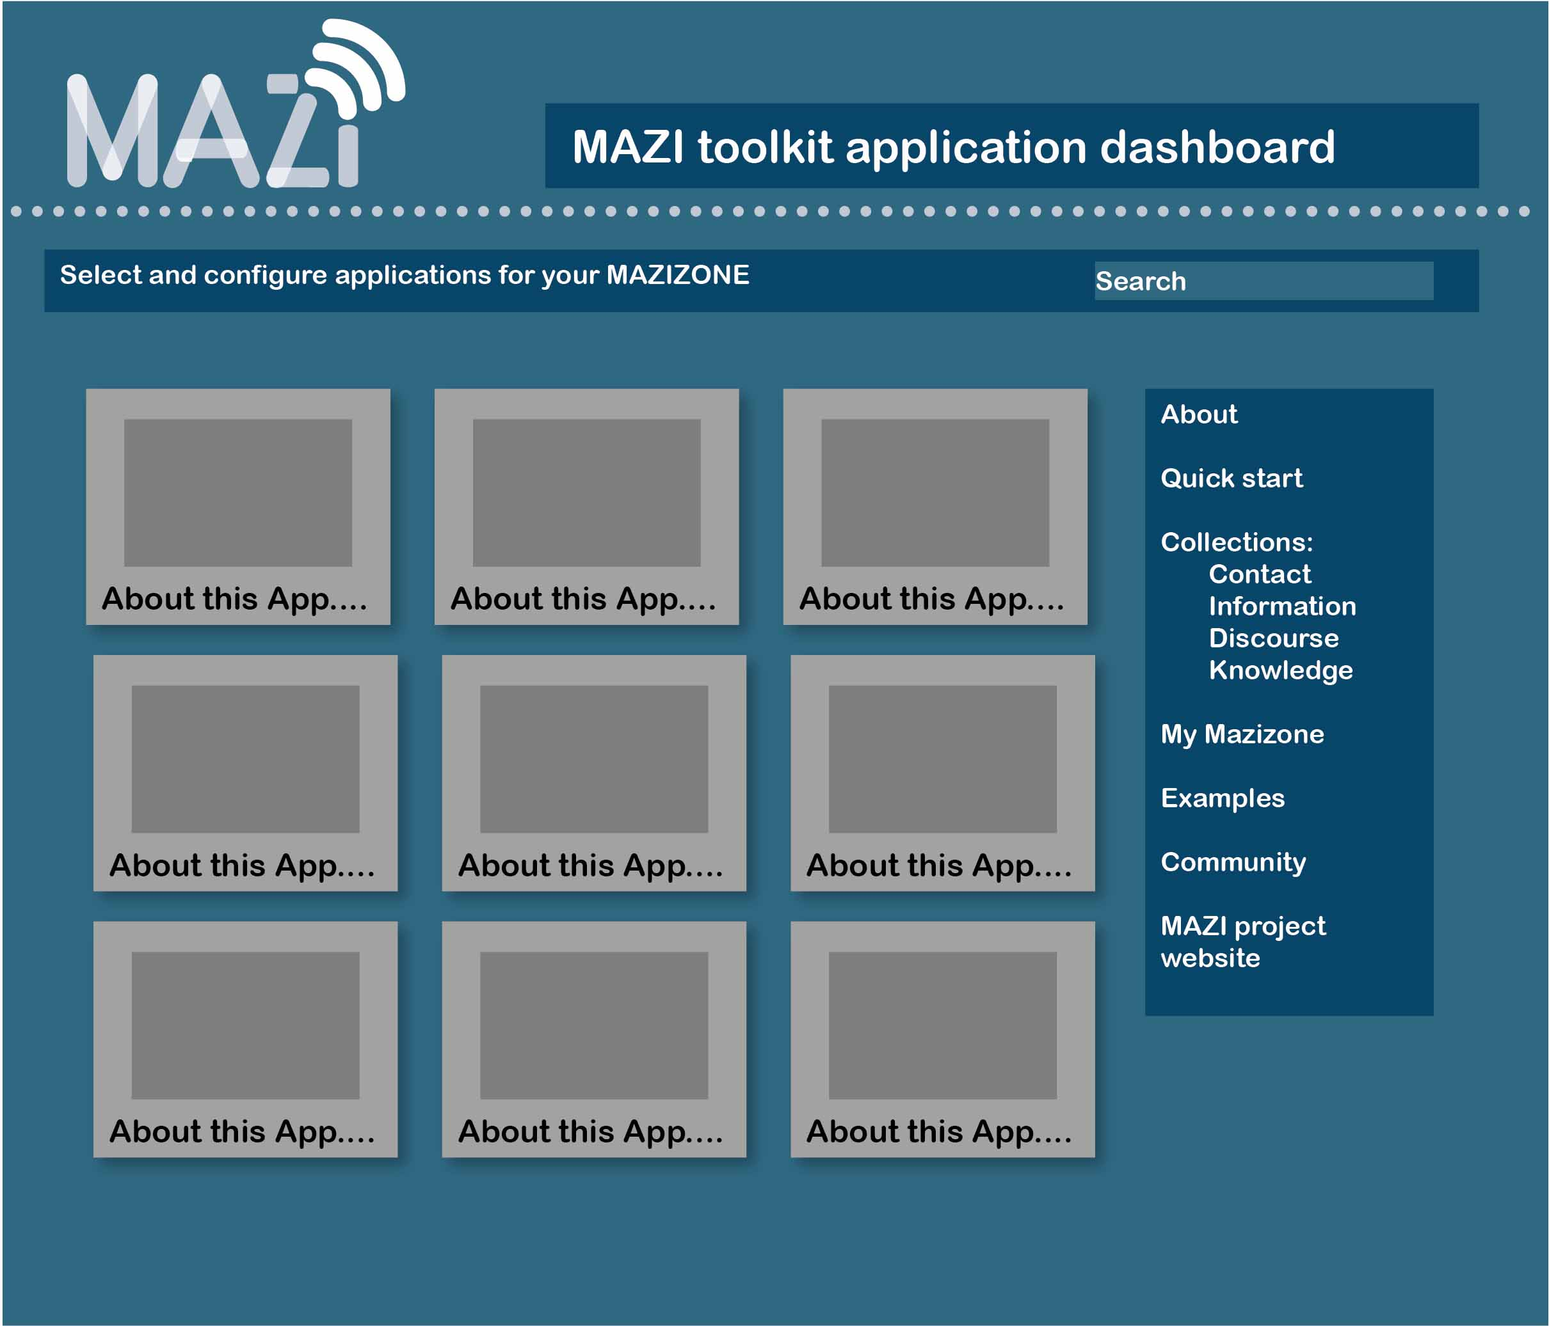
Example style of the web based Application Dashboard (element 2 above)

Further questions to be clarified:
- Key question: What is the order of events in setting up the mazizone? Do the users start by setting up a network on the PI, and then download and configure applications within the PI environment, or are applications and settings downloaded and packaged up, ready to be installed on a network?
See Activities Flowchart
- Should user accounts and logins be required to download apps from the Application Dashboard? Probably yes – should we include GitHub accounts?
Ideally yes – perhaps just a simple sign up to begin with involving creating a username and pw to access the apps. Initially users could have an app or data download limit per hour/day to prevent abuse.
- Where is the Configuration Dashboard located? Will it be included within a new version of the MAZI disk image? Does it make the setup process simpler by reducing the command line code?
System configuration dashboard should be included with the image, and accessible via local webpage on the device (e.g. In the same way that the playground is accessed by the end user)
This will require some form of authentication to be set up – e.g. either from the terminal during initial configuration or on first access to page etc.
- The mazizone configuration assumes connection to a monitor. Will the configuration settings remain as set after unplugging and used elsewhere, connected to a battery?
After configuration, settings will remain consistent.
A mazizone in this state will be accessible by end users with the addition of only a power cord (And any wifi connectors)
Changing of the settings by a configurator will be possible through the system settings portal on the device. However, accidental network misconfiguration here (such as disabling wifi) will require a monitor and keyboard to allow access for repair.

